α-cellulose extraction for isotopic measurements

Introduction
This protocol gives instructions on how to extract α-cellulose from plant material for isotopic measurements of oxygen-18 (¹⁸O) and carbon-13 (¹³C). ¹³C and ¹⁸O in plant material can give time-integrated information on water use efficiency and stomatal conductance of plants respectively.
The benefit of extracting α-cellulose and analysing its isotopic composition rather than analysing the bulk leaf samples is twofold: First, α-cellulose is a single component, which makes it easier to compare plants that have a different chemical composition (e.g. higher lignin contents due to different varieties). Secondly, after the formation of α-cellulose, oxygen atoms which are incorporated in the molecule remain stable and do not exchange with oxygen atoms of for example water. Therefore the isotopic signature of ¹⁸O of α-cellulose is specific to the time when the tissue was formed.
The extraction of α-cellulose can thus be used to assess water use efficiency and stomatal conductance of plants over multiple timeframes, but also to compare farm management (e.g. fertilizer application, planting density) performance under drought. However, this method does not serve the purpose of determining the cellulose content of the samples, as not all cellulose is recovered during the extracting process.

Literature
The extraction process is based on “Leavitt, S. W., & Danzer, S. R. (1993). Method for batch processing small wood samples to holocellulose for stable-carbon isotope analysis. Analytical Chemistry, 65(1), 87-89.”

Typical sample
- 200±5 mg dried and grinded (< 2 mm) plant material (to obtain approx. 5 mg α-cellulose; depending on type of plant material can be more)
- Approximate recovery of 64% of α-cellulose

Consumables and equipment
Consumables:
- Sodium Chlorite (80% purity)
Safety data sheet
(https://www.alfa.com/en/msds/?language=EN&subformat=CLP1&sku=14265)
- Acetic acid (96%)
Safety data sheet
(https://www.merckmillipore.com/AT/de/product/msds/MDA_CHEM-100062?Origin=PDP)
- Sodium Hydroxide
Safety data sheet
(https://www.sigmaaldrich.com/MSDS/MSDS/DisplayMSDSPage.do?country=AT&language=EN-generic&productNumber=221465&brand=SIGALD&PageToGoToURL=https%3A%2F%2Fwww.sigmaaldrich.com%2Fcatalog%2Fproduct%2Fsigald%2F221465%3Flang%3Dde)
- Distilled water
- Pure α-cellulose
- pH indicator strips, between pH 3-10
- Teflon bags (ANKOM F57 filter bags)
Needed equipment:
- Balance (±0.01 mg & 0.1 g)
- Heat sealer for ankom bags
- Magnetic stirrer + heater
- Water bath (shaking)
- Metal rings to weight down flasks
- Pipet (5 mL) +tip
- Forceps
- Funnel
- HDPE waste container
- Drying oven
- Heat protectors to hold hot glassware
Needed glassware:
- Erlenmeyer flask (500 mL)
- Beaker (500 mL)
- Beaker or Erlemeyer of 5 L
- Watch glasses to cover Erlenmeyer

Solution preparation
All preparations should be done in the fume hood since toxic gasses are produces! Extra care should be taken when handling the Sodium Chlorite. It is strongly recommended to wear a mask while working with the Sodium Chlorite powder

Acidified Chlorite reaction (lignin removal)
Add 10 g NaClO₂ to 350 mL H₂O in a beaker of 500 mL and stir until the solution clears out.
To start reaction, add 5 mL acetic acid (96%) to the solution. Add immediately to samples.

Bleaching reaction (hemi- and beta-cellulose removal)
Make a 17% NaOH solution (170 g NaOH flakes per L of water while stirring). Make sure to add the NaOH slowly to the water, as this reaction produces a lot of heat

Sample preparation
Procedure
Put sample numbers on the Teflon bags with a pencil (pencil is inert to chemicals and will not be washed off) | 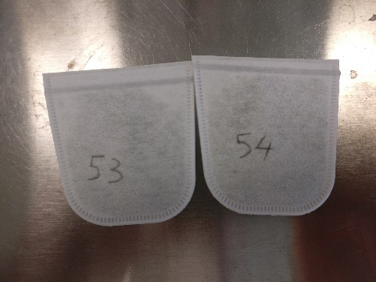
Fill Teflon bags with approx. 200 mg leaf sample | 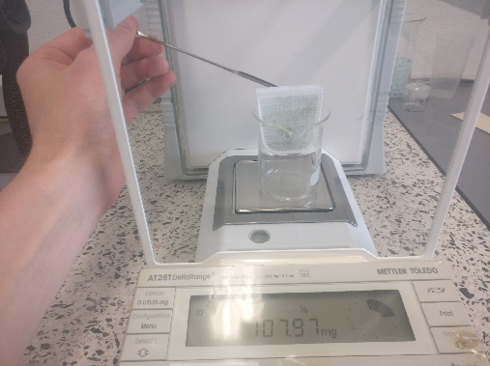
Include empty bags for blank weight correction, take tare weight and record value
Add samples of pure α-cellulose or lab standard to check the reproducibility between batches | 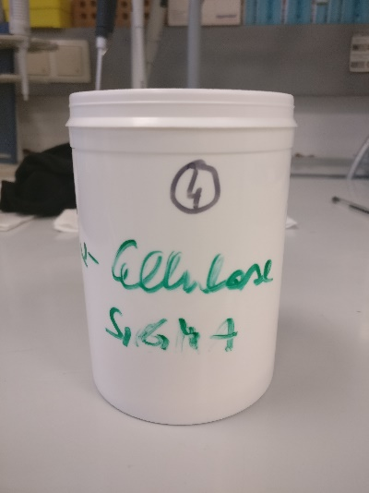
Heat seal the bags | 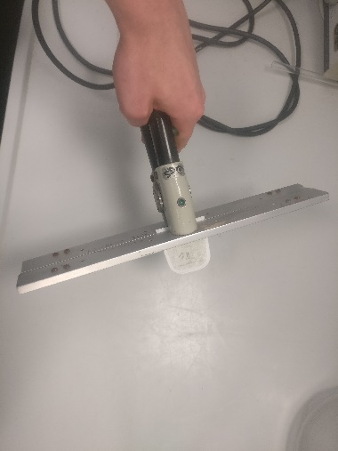

Acidified Chlorite reaction
Procedure
Switch on the water bath at 70°C | 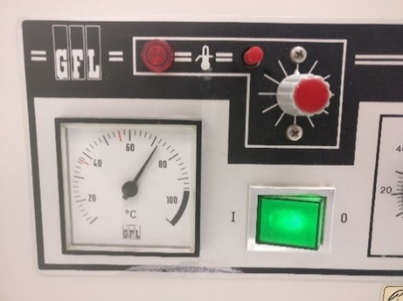
Put the samples in an 500 Erlenmeyer flask, max. 40 bags per flask (include 2 blanks and 2 pure cellulose per flask and write down which samples are in which flask) | 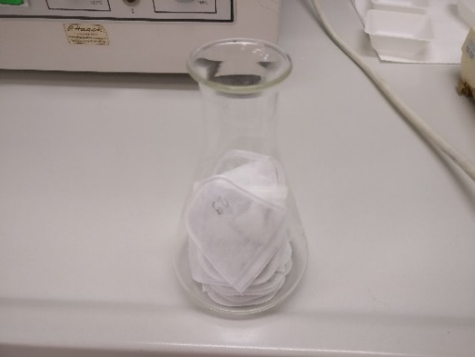
Caution: In the fume hood: Dissolve 10 g Sodium Chlorite (80%) in 350 mL distilled water on a magnetic stirring plate | 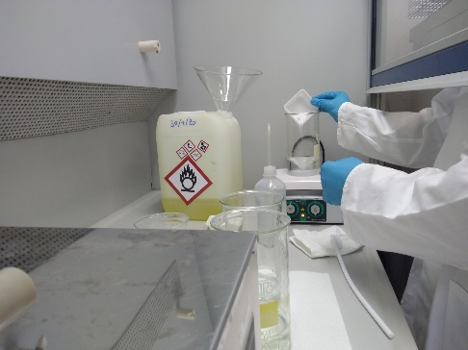
Add 5 mL Acetic Acid (96%) and immediately add the solution to the 500 mL Erlenmeyer flask | 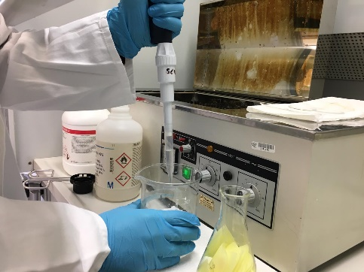
Incubate the solution containing the bags for 1 hour in the water bath at 70°C while shaking. Fix Erlenmeyer flasks with metal weights and put watch glasses on top of the Erlenmeyer.  Caution: Gas is produced in this step. This gas can be trapped between the bags and make the solution run over. Timely check and stir if needed. | 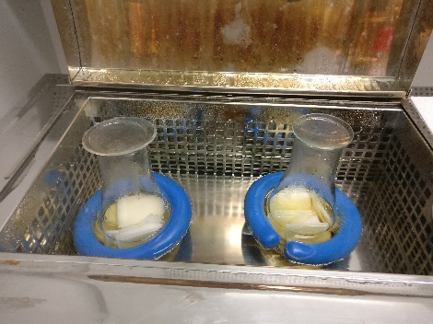
Take the Erlenmeyer flasks out of the bath and pour the solution in a special waste container | 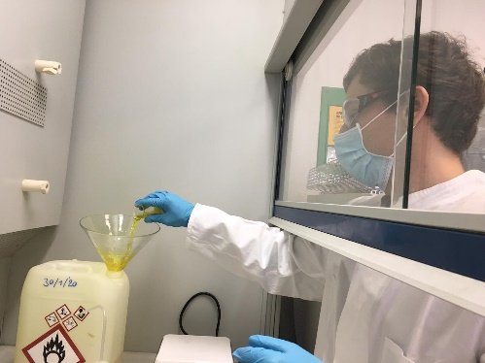
Push with forceps on the bags in order to remove the leftover solution
Repeat these steps 5 more times

Washing step
Procedure
Prepare hot water (~80°C) | 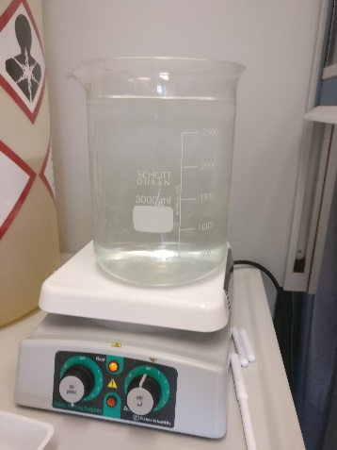
Add hot water to the emptied Erlenmeyer flasks and squeeze the bags with forceps | 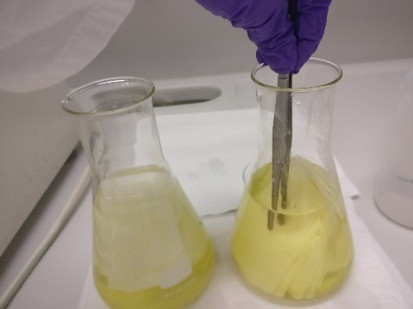
Collect the hot water in the waste container and repeat this washing step two times with hot water
Wash with cold water until a neutral pH is reached. This water can go to the normal drain. | 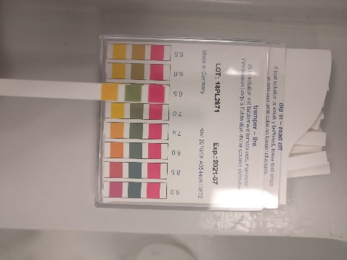

Bleaching reaction
Procedure
Prepare a 17% NaOH solution by adding59.5 g to 350 ml of H₂O. Make sure to add water to the beaker before adding NaOH  Caution: Dissolving NaOH is an exothermic reaction. Add NaOH pellets slowly to the water and bit by bit. | 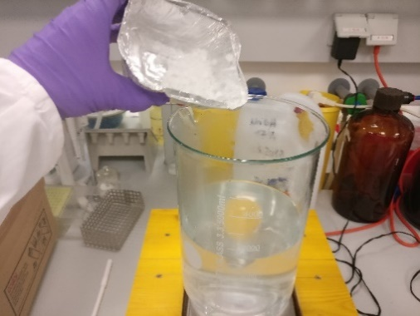
Switch on the water bad at 70°C | 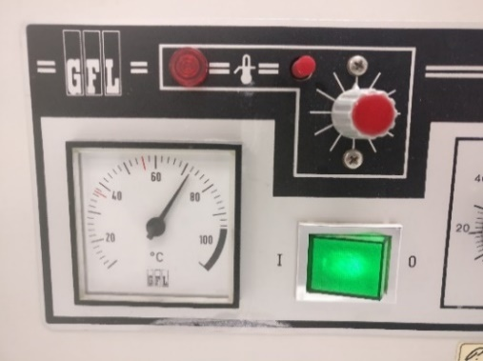
Add 350 mL of bleaching solution to the Erlenmeyer flasks and incubate for 45 minutes while shaking. Discard solution in another waste container. Use forceps to squeeze leftover solution out of the bags. | 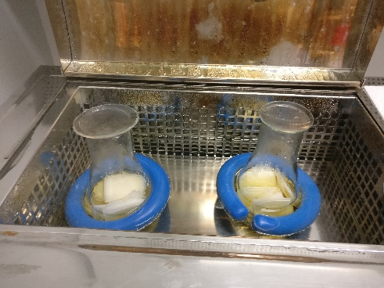
Repeat the previous step 2 more times.
Wash with cold water until a neutral pH is reached. Waste can be disposed off in the sink. | 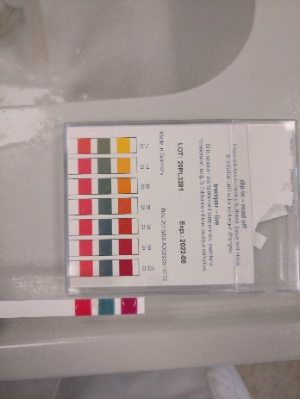  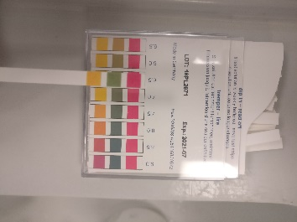

Acidified Chlorite reaction
Procedure
Switch on the water bath at 70°C | 
Put the samples in Erlenmeyer flasks | 
Dissolve 10 g Sodium Chlorite (80%) in 350 mL distilled water on a magnetic stirring plate | 
Add 5 mL Acetic Acid (96%) and immediately add the solution to the Erlenmeyer flasks (be careful, toxic gasses are produced, carry out every step in the fume hood) | 
Incubate the solution containing the bags for 1 hour in the water bath at 70°C while shaking. Fix Erlenmeyer flasks with metal weights | 
Take the Erlenmeyer flasks out of the bath and pour the solution in a special waste container | 
Push with forceps on the bags in order to remove the leftover solution
Repeat these steps 1 more time

Washing step
Procedure
Prepare hot water (~80°C) | 
Add hot water (~350 mL) to the emptied Erlenmeyer flasks and squeeze the bags with a forceps | 
Collect the water in the waste container and repeat this washing step two times with hot water
Wash with cold water until a neutral pH is reached | 

Further sample processing
Procedure
Squeeze Teflon bags to remove water and put the bags in the oven at 70°C overnight
Weigh the empty bags, cellulose bags and sample bags on the balance
Open the Teflon bag gently by cutting the upper sealed part off
Collect sample in glass plate by scraping it off from the sides of the Teflon bags
Weigh minimum 0.20 mg of cellulose sample in tin cups and prepare for analysis with IRMS

Recovery calculations
Procedure
Calculate the average percentual loss in weight of the empty bags
Calculate how much cellulose is still left in the bags based on the weight loss of the empty bags and final weight of the bags containing cellulose. With this you can calculate the cellulose recovery.
Calculate the percentage of cellulose in your samples

